Visit Section Master

Section Master is used to create the different section of the template. Like complaints, Past, Family & Personal History, Current Medication, General Examination, Obstetrics & Gynecology History, Systemic Examination, Advice & Recommendations etc.
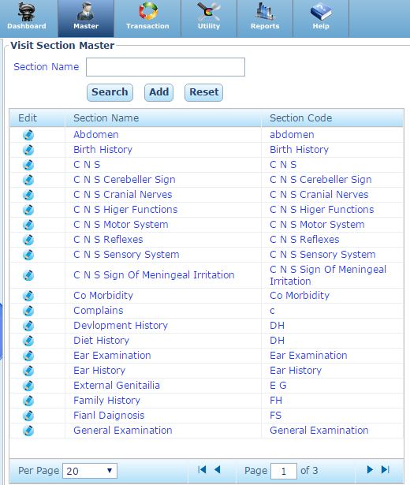

Add New Visit Section Master:
To Add the New section, we have to select the name & Code of the section and then save.
Section Name: Enter the Name of the Section
Section Code: Enter the Code of the Section
Visit Specific: Check if the section is visit specific.
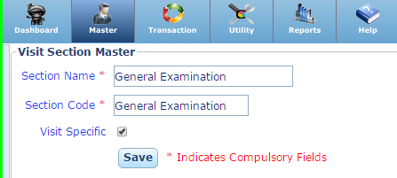
Search: You can search a section by its name.
Reset: To clear the text of the section name.

Template Item Category

We can create the template in different category. We can create the category in Template Item Category Master.
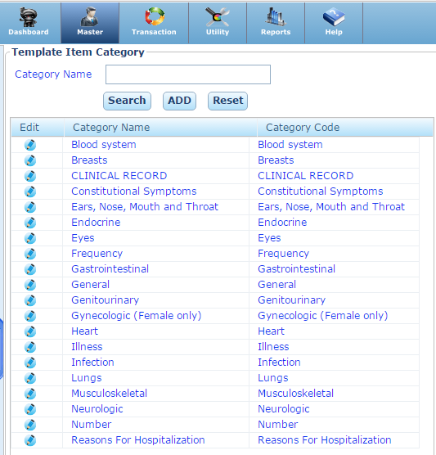

Add: To Add New a Template Item Category, click on the add button and enter the category name and code & save.
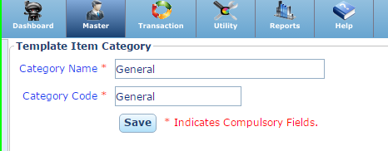
Search: You can search a section by its name.
Reset: To clear the text of the section name.

Template Item:
It is used to create the items which in which inputs are taken.
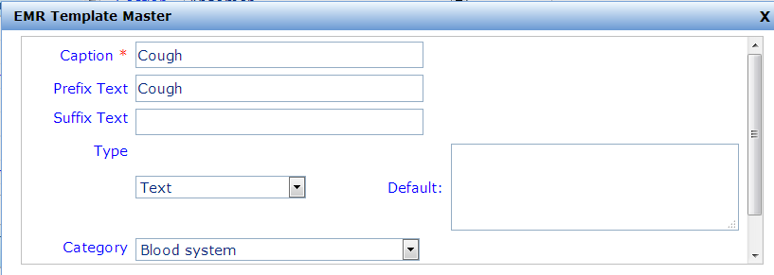
Caption: Enter the Caption Name.
Prefix: Enter the caption for prefix of Item Template.
Suffix: Enter the caption for suffix of Item Template.
Type of Item Template: Select the type of Item.
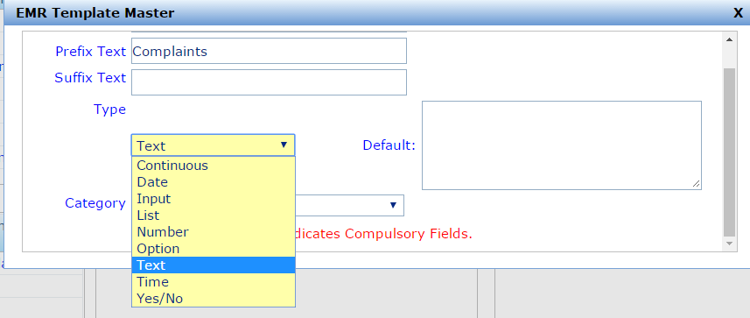
Default: Enter the default value of the Item Template.

- Continuous: If Item contain another Item Template like
- Date: Select the type of the Item date of the answer is date like Start or End date, Date of Vaccination etc.
Note: We can select the default date if required.
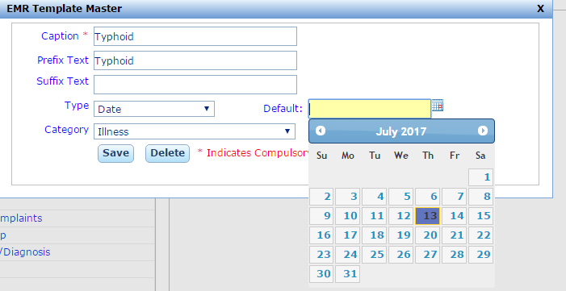
- Input: if type of the Item Template is input. Then we can add a new Template run time at the time of OPD Entry.
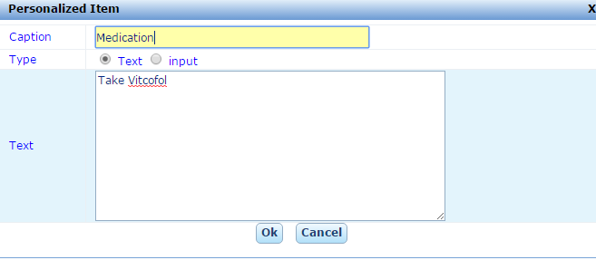

- List: if type of the Item Template is List. Then we can add a new Template run time at the time of OPD Entry.
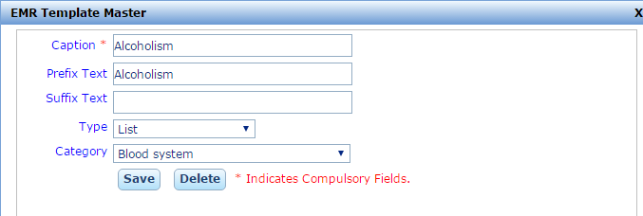
- Number: If the answer of the Item Template is in form of Numbers.
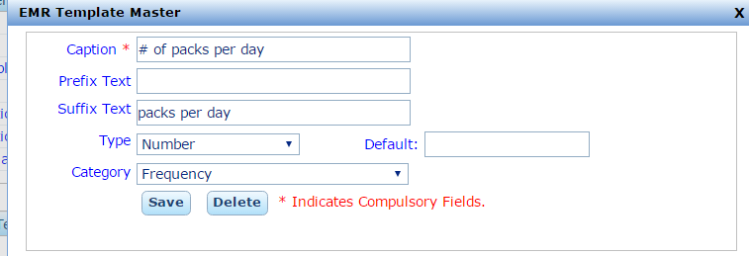
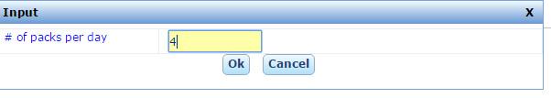

- Option: if type of the Item Template is Option. Then we can add a new Template run time at the time of OPD Entry.
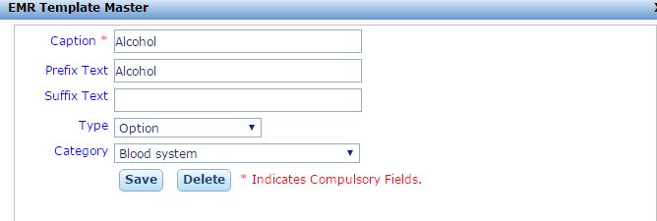
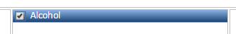
- Text: If the input of the Item Template is in form of the text then choose the type is text.
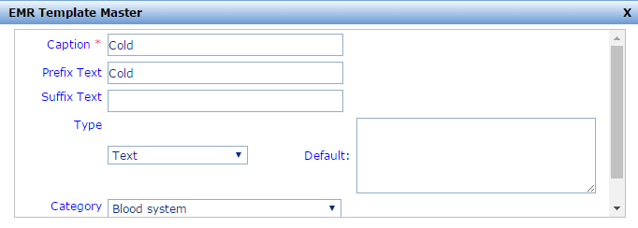
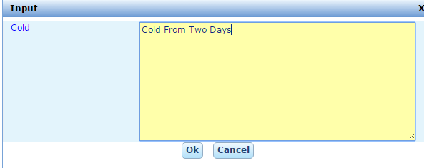

- Time: If the input of the Item Template is time then select the type time.
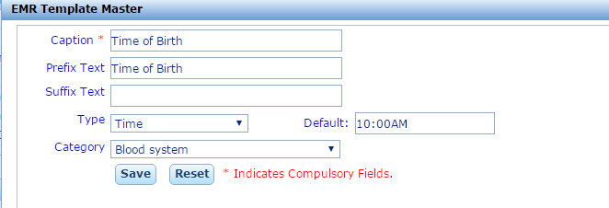
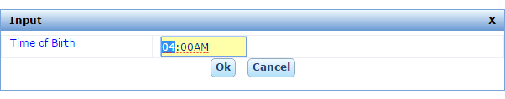
- Yes/No: If the input of the Item Template is Either yes or no then select type is Yes/No.
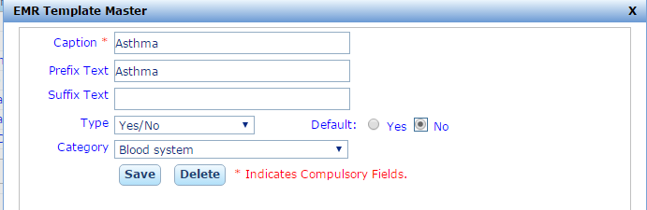

Template Master

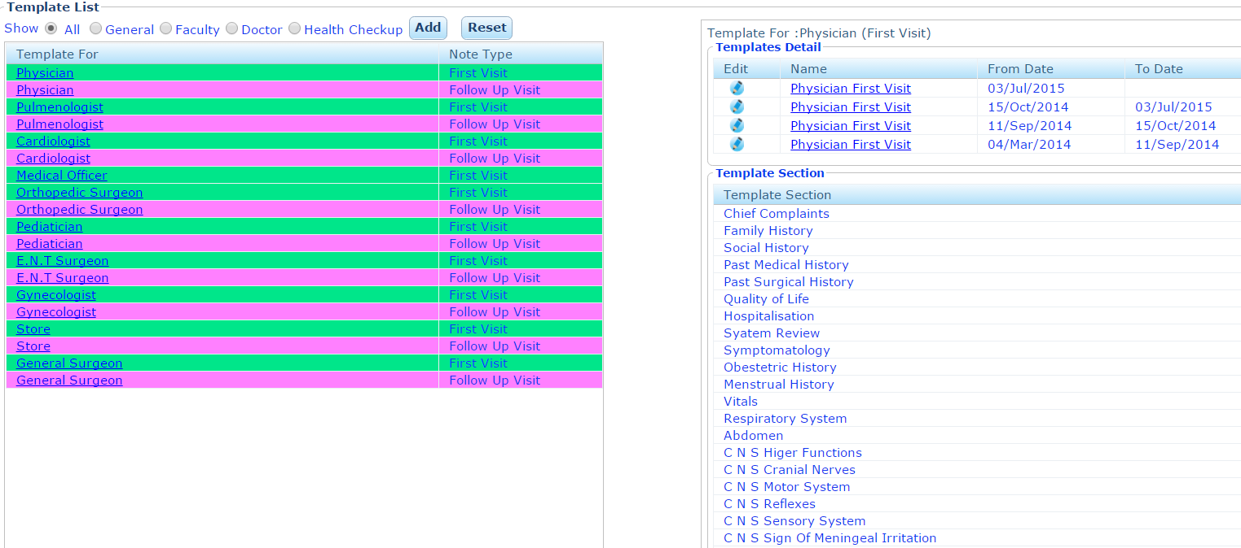

Process to create Template

- Template Name: Enter the Name of the Template.
- Template Used For: Faculty / Doctor/ Health Check Up.
Visit Type: First Visit / Follow-up.
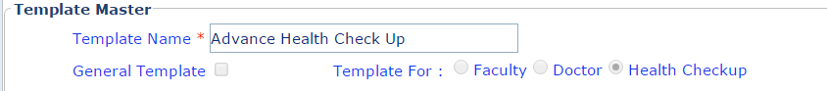
- Template Used for: Faculty
- Template Used for: Doctor
- Template Used for: Health Check Up
- Select Default/ Inbuilt Template: Choose the list of General Template & save.
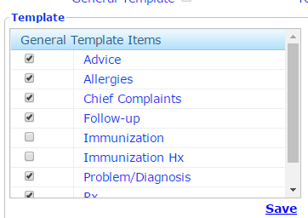

- Select Section Master: Select the section of the template.
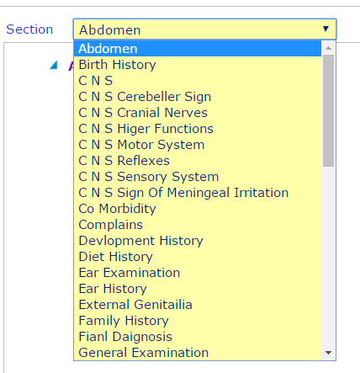
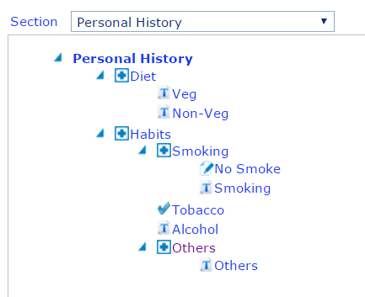

- Add Item Template from Item Template List
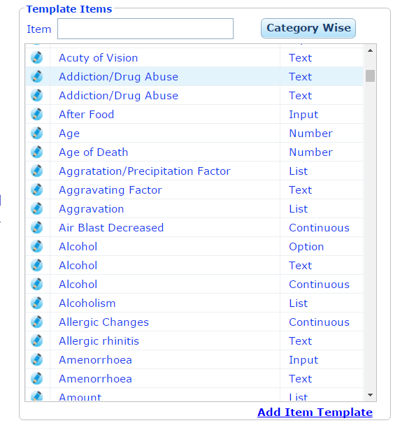

- Add New Item Template

